Test Case: tc001_SPX_Dev5_Crear_Requisicion_Spot_Tipo_Cobro_CC
Step 1 - Enter username and password and click to button Enter : Credentials Entered
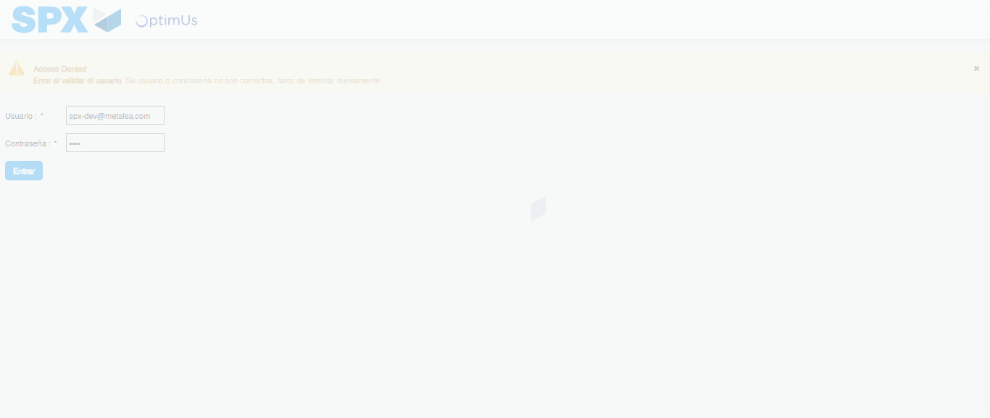Image file-name: QC_Testing-tc001_SPX_Dev5_Crear_Requisicion_Spot_Tipo_Cobro_CC-1782164711987

Step 2 - Select to UEN and Access to Spot Buy Requisitions : UEN Correctly selected and Correct access
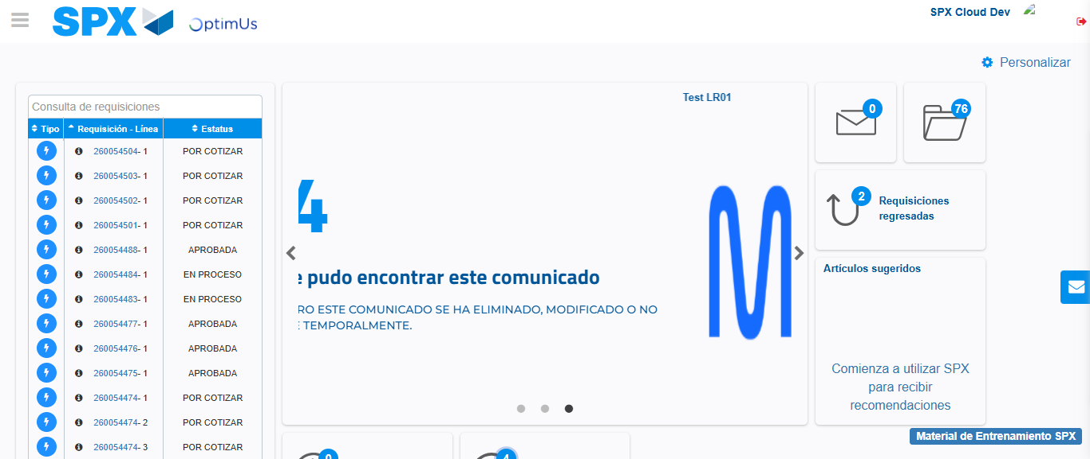Image file-name: QC_Testing-tc001_SPX_Dev5_Crear_Requisicion_Spot_Tipo_Cobro_CC-1782164744692

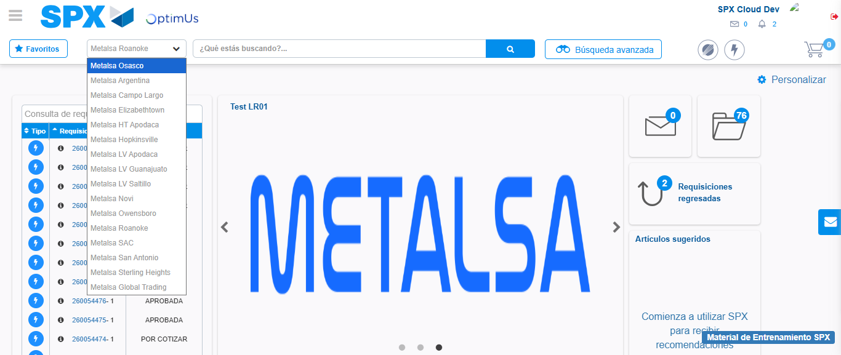Image file-name: QC_Testing-tc001_SPX_Dev5_Crear_Requisicion_Spot_Tipo_Cobro_CC-1782164749832

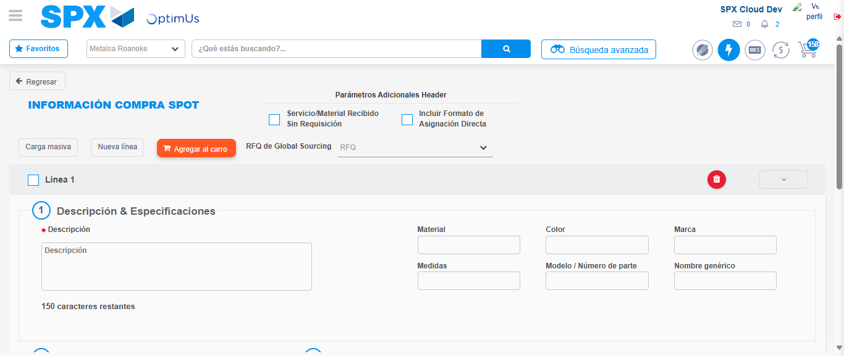Image file-name: QC_Testing-tc001_SPX_Dev5_Crear_Requisicion_Spot_Tipo_Cobro_CC-1782164762290

Step 3 - Data Capture Spot Buy Requisition : Data captured correctly
Image file-name: QC_Testing-tc001_SPX_Dev5_Crear_Requisicion_Spot_Tipo_Cobro_CC-1782164762531

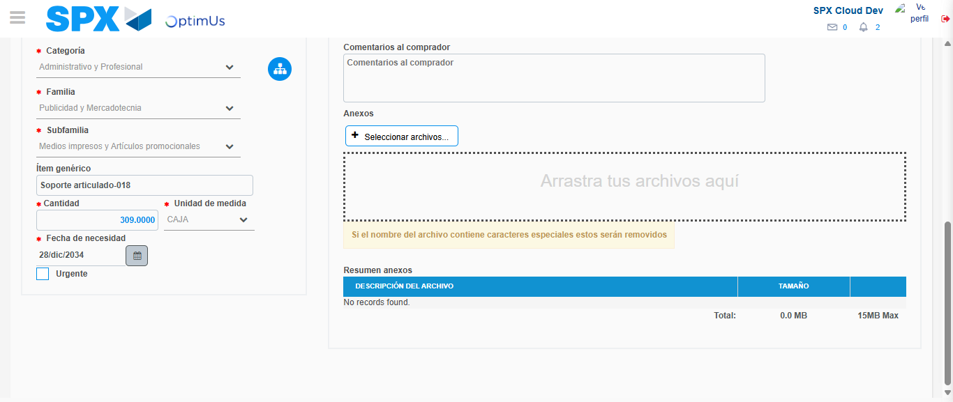Image file-name: QC_Testing-tc001_SPX_Dev5_Crear_Requisicion_Spot_Tipo_Cobro_CC-1782164774320

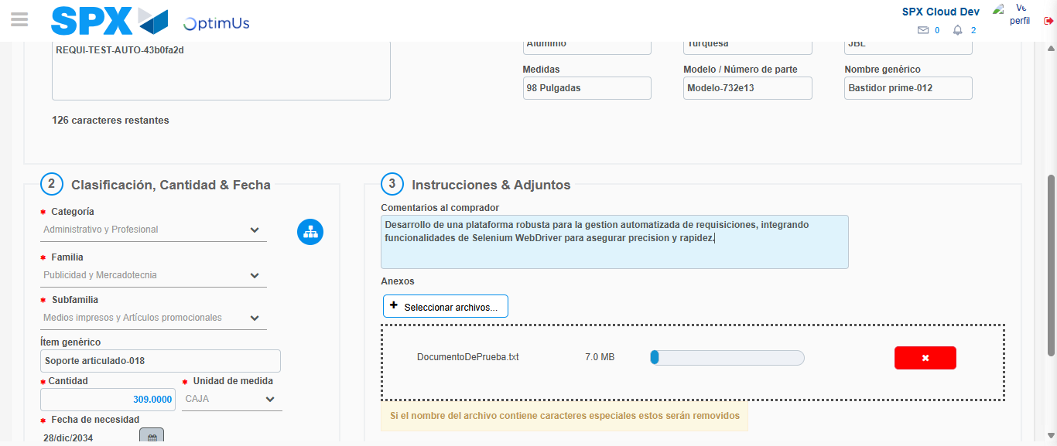Image file-name: QC_Testing-tc001_SPX_Dev5_Crear_Requisicion_Spot_Tipo_Cobro_CC-1782164775054

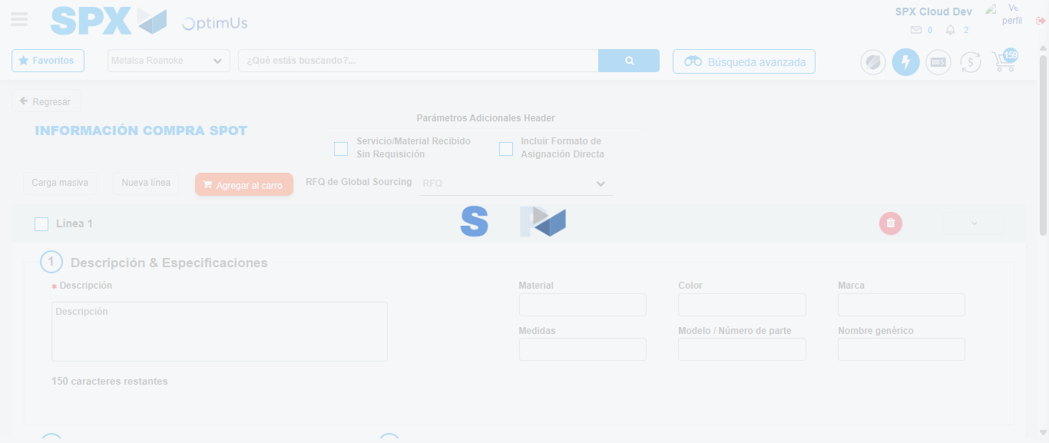Image file-name: QC_Testing-tc001_SPX_Dev5_Crear_Requisicion_Spot_Tipo_Cobro_CC-1782164779044

Step 4 - Select to Requisition : Requisition Correctly selected
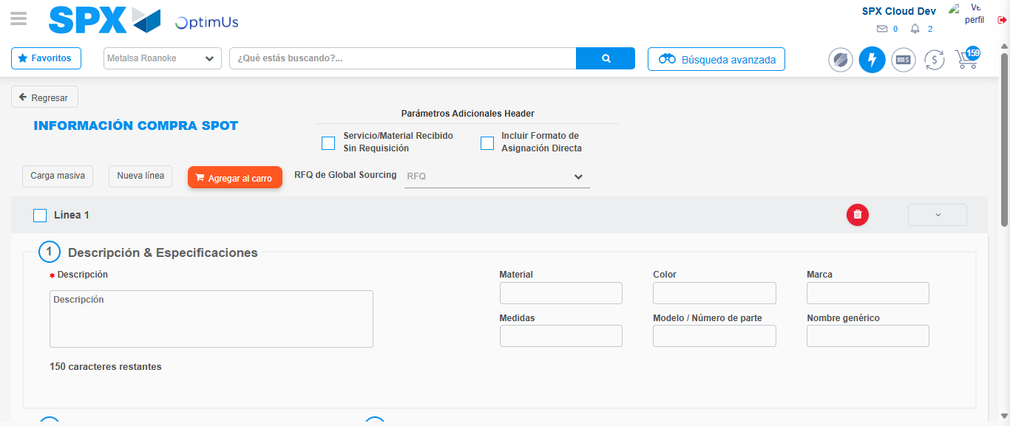Image file-name: QC_Testing-tc001_SPX_Dev5_Crear_Requisicion_Spot_Tipo_Cobro_CC-1782164779250

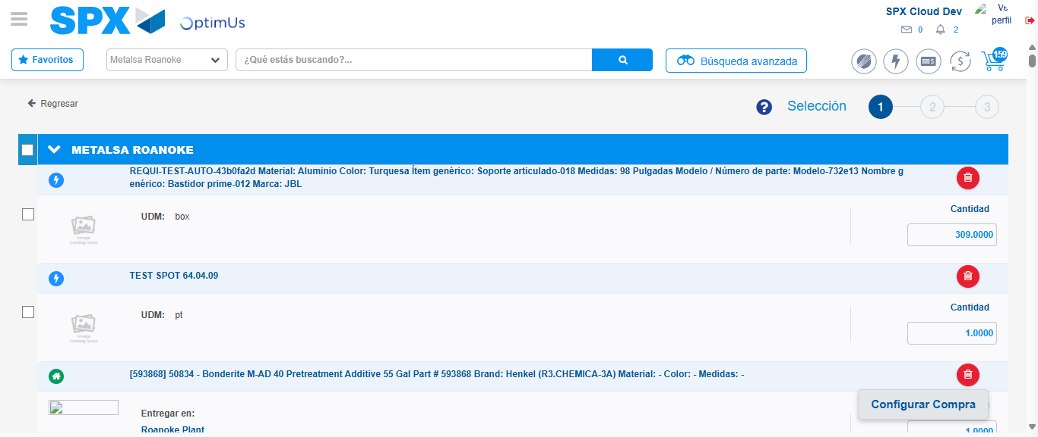Image file-name: QC_Testing-tc001_SPX_Dev5_Crear_Requisicion_Spot_Tipo_Cobro_CC-1782164793020

Image file-name: QC_Testing-tc001_SPX_Dev5_Crear_Requisicion_Spot_Tipo_Cobro_CC-1782164793229

Image file-name: QC_Testing-tc001_SPX_Dev5_Crear_Requisicion_Spot_Tipo_Cobro_CC-1782164793458

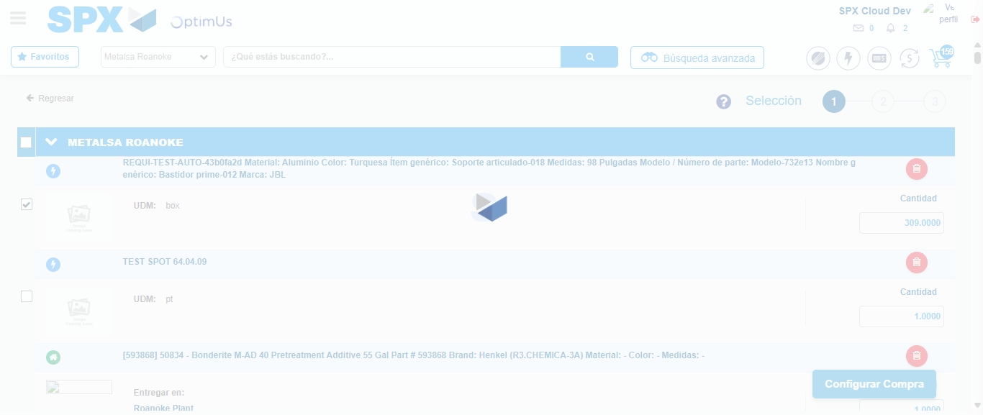Image file-name: QC_Testing-tc001_SPX_Dev5_Crear_Requisicion_Spot_Tipo_Cobro_CC-1782164795354

Step 5 - Select Type Account For Requisition : Type Account Correctly selected
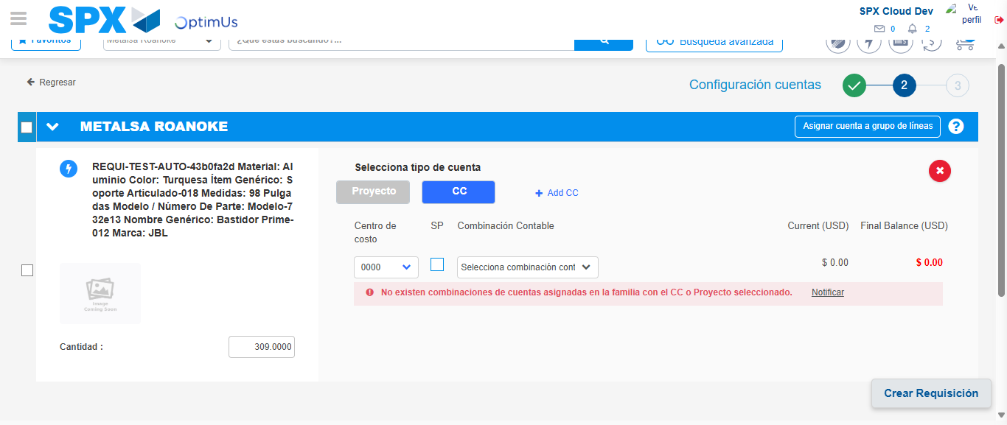Image file-name: QC_Testing-tc001_SPX_Dev5_Crear_Requisicion_Spot_Tipo_Cobro_CC-1782164809409

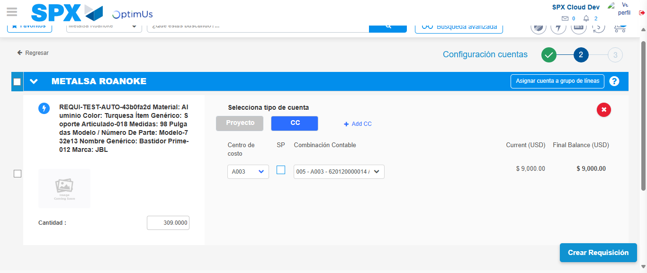Image file-name: QC_Testing-tc001_SPX_Dev5_Crear_Requisicion_Spot_Tipo_Cobro_CC-1782164814663

Image file-name: QC_Testing-tc001_SPX_Dev5_Crear_Requisicion_Spot_Tipo_Cobro_CC-1782164814860

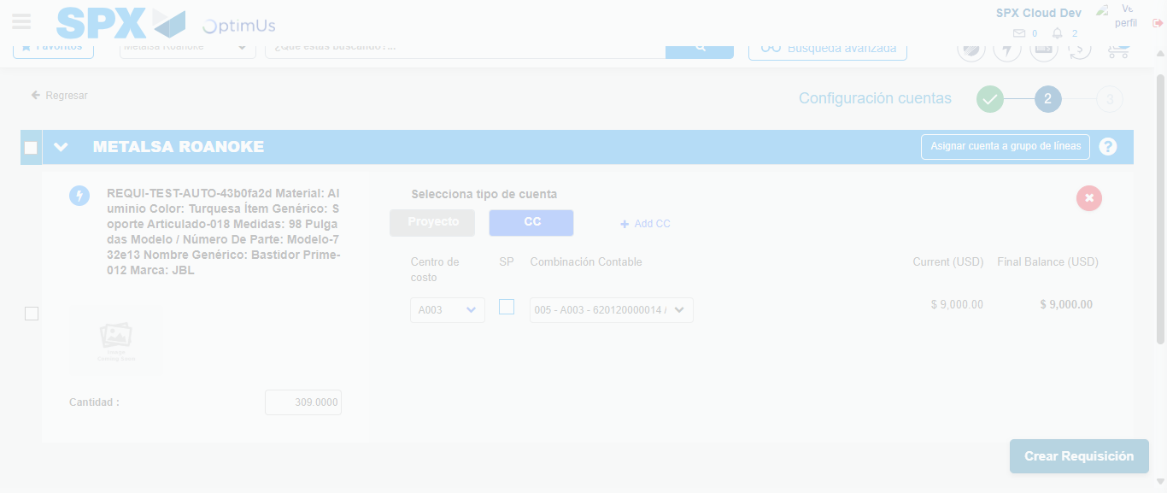Image file-name: QC_Testing-tc001_SPX_Dev5_Crear_Requisicion_Spot_Tipo_Cobro_CC-1782164815253

Step 6 - Accept to Requisition : Requisition Accepted
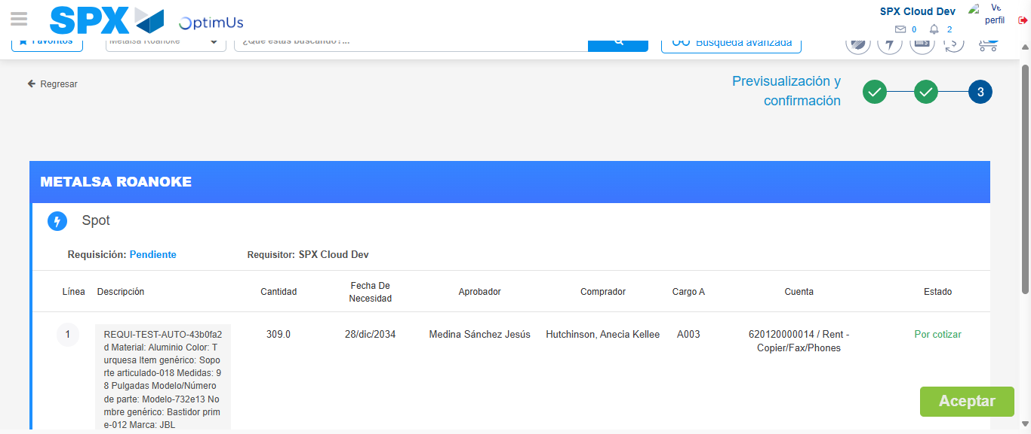Image file-name: QC_Testing-tc001_SPX_Dev5_Crear_Requisicion_Spot_Tipo_Cobro_CC-1782164816053

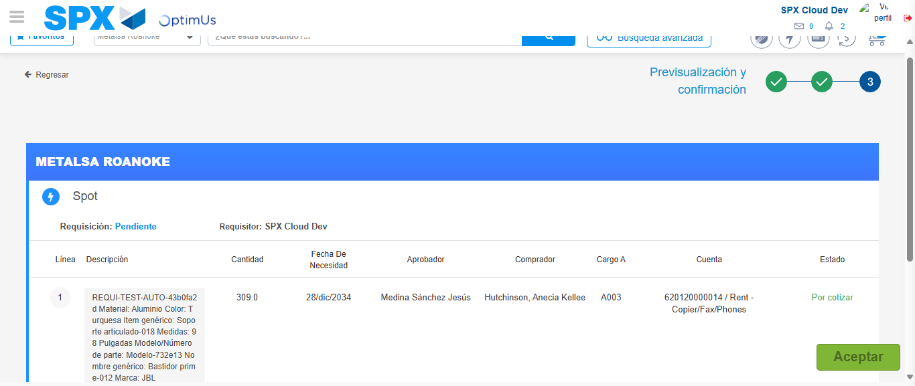Image file-name: QC_Testing-tc001_SPX_Dev5_Crear_Requisicion_Spot_Tipo_Cobro_CC-1782164816297

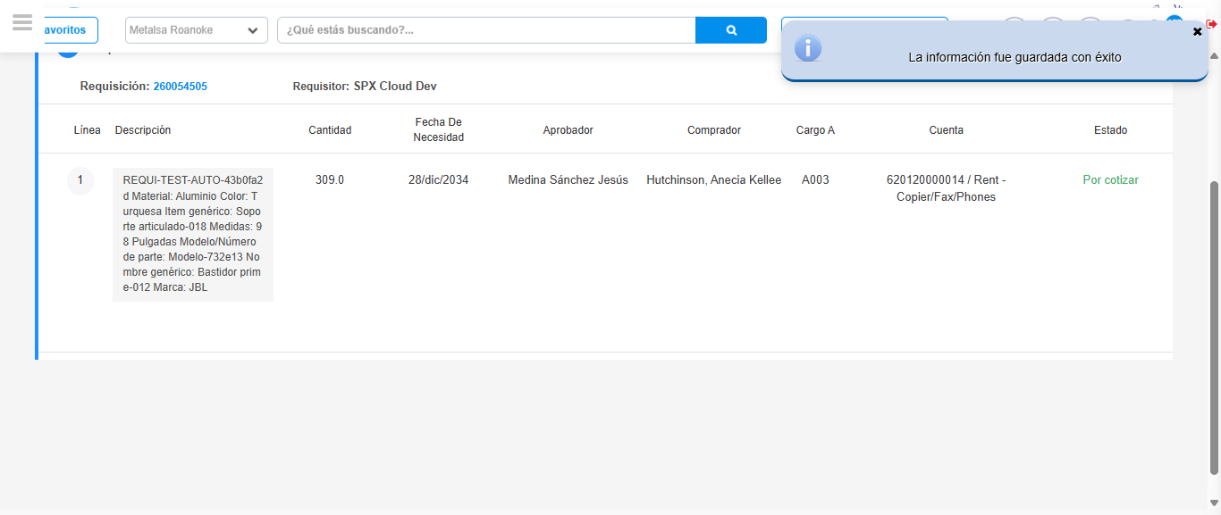Image file-name: QC_Testing-tc001_SPX_Dev5_Crear_Requisicion_Spot_Tipo_Cobro_CC-1782164819245

Step 7 - Return to Main Page SPX : Return to Main Page SPX
Image file-name: QC_Testing-tc001_SPX_Dev5_Crear_Requisicion_Spot_Tipo_Cobro_CC-1782164744692

Image file-name: QC_Testing-tc001_SPX_Dev5_Crear_Requisicion_Spot_Tipo_Cobro_CC-1782164749832

Image file-name: QC_Testing-tc001_SPX_Dev5_Crear_Requisicion_Spot_Tipo_Cobro_CC-1782164762290

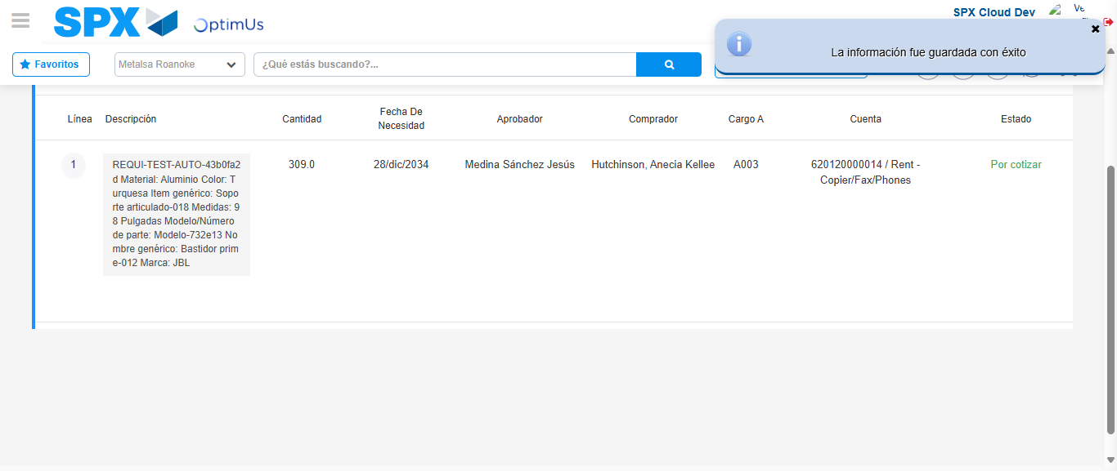Image file-name: QC_Testing-tc001_SPX_Dev5_Crear_Requisicion_Spot_Tipo_Cobro_CC-1782164821477

Image file-name: QC_Testing-tc001_SPX_Dev5_Crear_Requisicion_Spot_Tipo_Cobro_CC-1782164821631

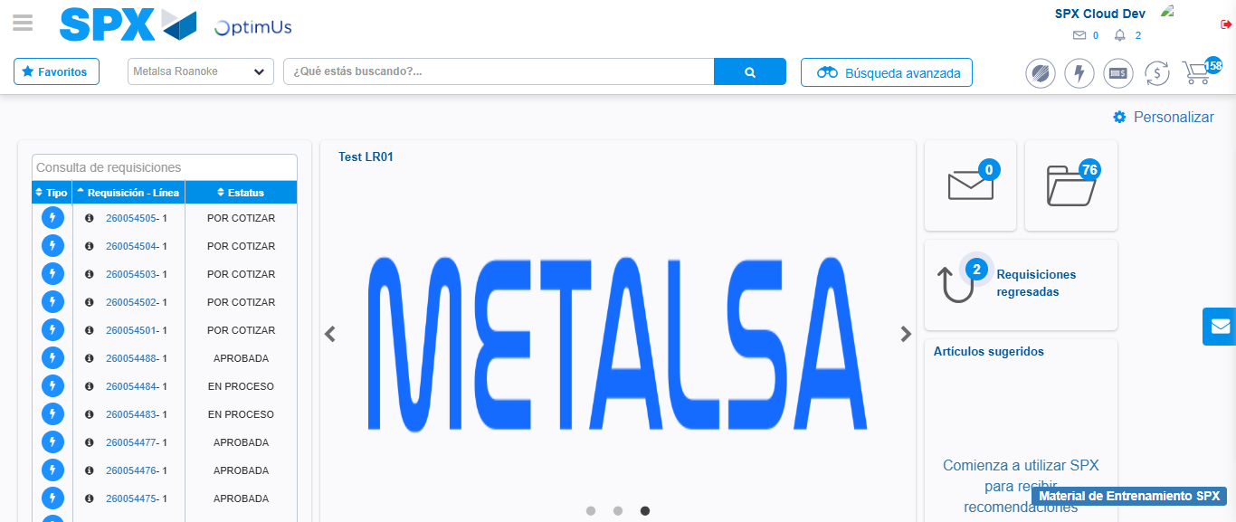Image file-name: QC_Testing-tc001_SPX_Dev5_Crear_Requisicion_Spot_Tipo_Cobro_CC-1782164842643

Step 8 - Log Out : Log Out SPX
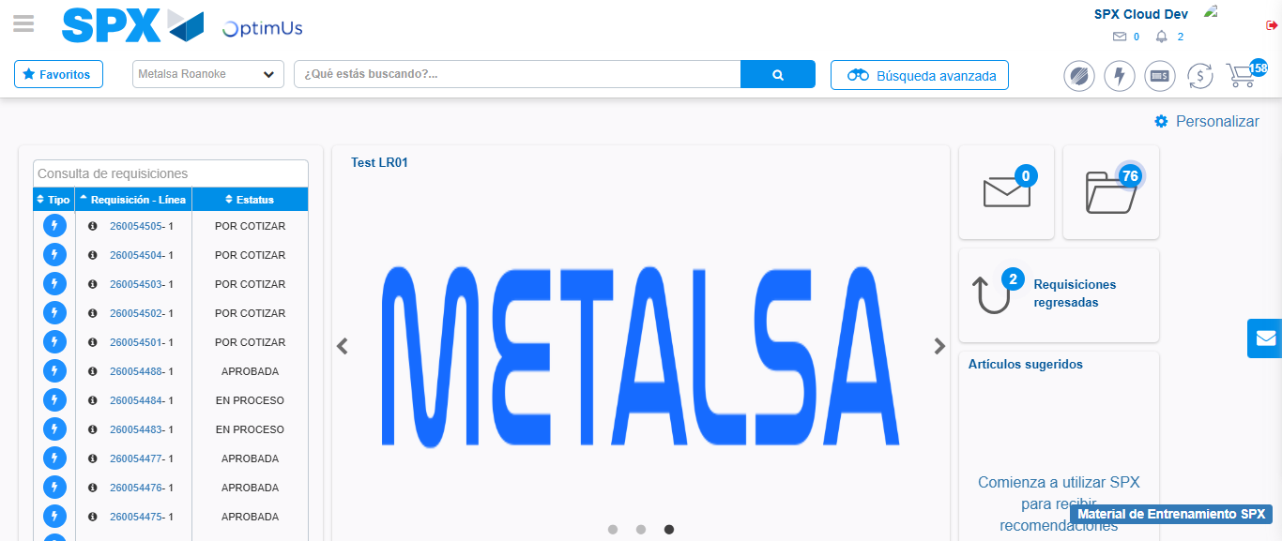Image file-name: QC_Testing-tc001_SPX_Dev5_Crear_Requisicion_Spot_Tipo_Cobro_CC-1782164842898

